Introduction
The COVID-19 pandemic, also known as the coronavirus pandemic of coronavirus disease 2019 (COVID-19), caused by severe acute respiratory syndrome coronavirus 2 (SARS-CoV-2).
The virus is particularly deadly and has a propensity to spread easily. At time of writing this policy over forty thousand people had died because of it in the UK.
As a result of the potential of this disease to have a massive burden on the country a “lockdown” was enforced by the UK government on the 23rd March 2020. Weymouth Physiotherapy ceased treating people face-to-face at this point.
Relaxation of this lockdown by the government started in May 2020 and services including physiotherapy were given permission to open up.
This policy sets out everything Weymouth Physiotherapy is implementing in order to manage risk when it reopens following this relaxation.
This is in accordance with advice from the governing body, the Charted Society of Physiotherapists (CSP), physiotherapists regulatory body, the Health Care and Professions Council (HCPC) as well as advice from Physio First (an affiliate business linked to the CSP which focuses on private practice physiotherapy). Government, Public Health England (PHE) and Health and Safety Executive (HSE) policies and guidelines are embedded in to this.

Virtual First Approach
As recommended by the Chartered Society of Physiotherapy, Weymouth Physiotherapy is using a “virtual first” approach. This means that all patients will be assessed in some capacity before any face-to-face consultation can take place. This may be in the form of a telephone call or using video conferencing software.
Where possible patients will be managed using these virtual means however there may be occasions where the patient needs to attend for face-to-face appointments. The decision to bring a patient in for a face-to-face needs to be agreed by both clinician and patient and must be decided by weighing up the risk of transmission of the virus with the benefits a face-to-face appointment over a virtual appointment.
The ability to use virtual means should be reviewed after each appointment attended.

Assessing clinical need for face to face appointments
As mentioned above the decision to have a patient attend for a face-to-face appointment can only happen after all risks have been considered. This has to be done on a case-by-case basis and the decision is to be made jointly between the clinician and the patient.
Assessing a patients needs will be done either on the telephone or using our video conferencing software. The risks and how they have been managed are contained in our clinical reasoning form.
Examples where a face-to-face appointment may be appropriate include:
- Patient has no access or limited access to video conferencing and cannot be assessed adequately over the phone.
- Patient does not have the space or equipment at home to have a suitable appointment through virtual means.
- In order to accurately diagnose a patient it is important to do a hands-on assessment, where a lack of clarity on the diagnosis could lead to a worse outcome for the patient. This may include suspected serious pathology.
- In order to best treat a patient they need to come in for hands – on treatment where otherwise their outcome would be significantly poorer.
- Patient is in escalating or is likely to deteriorate unless a face-to-face appointment takes place.
- Pain is negatively affecting mental health and is likely to deteriorate unless a face-to-face appointment takes place.
- Patient is not responding to self-management or virtual treatment or is not willing to engage in virtual treatment and in doing so is going to get a worse outcome.
This list is not exhaustive, nor does it mean if patient meet the criteria then they should automatically be given a face-to-face appointment. All decisions are individual to the patients needs

The following factors make the decision to offer a face-to-face appointment significantly less likely. These are people in the extremely vulnerable (shielded) group according to government guidelines
- People undergoing active cancer treatment
- People with solid organ transplants
- People with severe respiratory conditions
- People with rare diseases which increase the risk of infection
- People on immunosuppression that significantly increases the risk of infection

The following factors may make a decision to proceed to a face-to-face appointment less likely. These are people in the clinically vulnerable group according to government guidelines
- Aged 70 or older
- Under 70 and with any of the following health conditions
- Chronic (Under 70 and underlying health condition listed below (anyone instructed to get a flu jab on medical grounds)
- Chronic (long-term) mild to moderate diseases such as asthma, COPD, emphysema, or bronchitis
- Chronic heart disease such as heart failure
- Chronic kidney disease
- Chronic Liver Disease such as hepatitis
- Chronic neurological conditions such as Parkinson’s disease, motor neurone disease, multiple sclerosis or cerebral palsy
- Diabetes
- A weakened immune system as the result of certain conditions, treatments like chemotherapy or medicines such as steroid tablets
- Being seriously overweight (BMI 40 or above)
- Pregnant women

Again these lists are not exhaustive they are considerations to think about when deciding whether a face-to-face appointment is appropriate.
The decision tree below shows the pathway to a face-to-face or virtual appointment
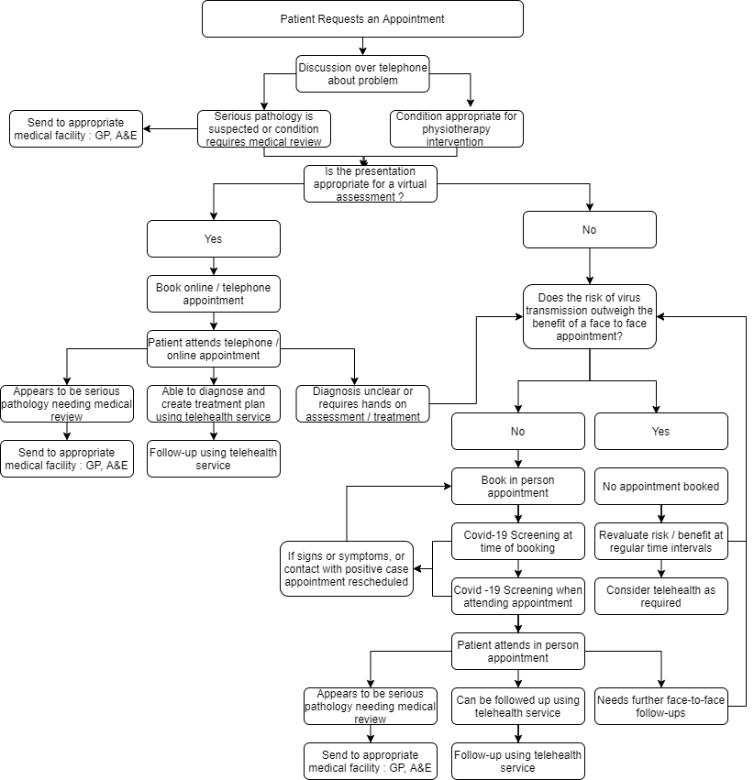

Record keeping
All decisions about whether or not to have face-to-face or a virtual appointment needs to be documented thoroughly at all times. This should include the specific factors discussed and the clinical reasoning applied to the decision. A clinical decision making form is on Writeupp and can help guide this process.
COVID-19 Screening
All patients due to attend a face-to-face appointment will undergo COVID-19 screening. This will take place at the time of booking, by the patient independently leading up to their appointment with prompting and then when being called up to their appointment.
The following will be determined
- Whether a patient has had symptoms of coronavirus as classified by the UK government. Currently this includes: a fever (temperature higher than 37.9), a dry persistent cough, and a loss of taste or smell
- Whether a patient has confirmed coronavirus
- Whether a patient has knowingly been in close contact with a confirmed case of coronavirus or someone with symptoms as above within the last 14 days. The exception to this is if they are medical / care professional and have worn adequate PPE.
- Whether they have been asked to self-isolate by the governments track and trace team
Any patient who meets these criteria will not be able to attend their appointment face-to-face and will be asked to rebook. The exception of this is where it is important to see the patient to rule out sinister pathology. Should this be needed a risk analysis needs to take place and referral direct to the appropriate healthcare system needs to be considered.
The outcome of the COVID-19 screen needs to be clearly documented within the notes.

Social Distancing
The virus is primarily spread between people during close contact via airborne transmission or by contact transmission. It is therefore important that we minimise the time clinician and patients spend in close proximity and also to minimise time spent in contact with others. The following procedures will allow this
- There will be no waiting room. Instead patients will be asked to wait outside or in their cars. When the clinician is ready for them they will be called on their telephone
- Patients will enter and leave via the backdoor to the building as this will reduce the risk of them coming in to contact with other people in the building. They will be asked to adhere to government social distancing rules once in the building.
- Where possible assessment and treatment will take place at a distant of more than 2m, there is ample clinic space to allow this. Chairs will be spaced accordingly
- Where close contact of less than 2m is required, the time spent within this distance will be minimised and should ideally be less than 15 minutes in each session in accordance with advice from Physio First.
- Patients should attend alone. The attendance with a friend, family member, carer or advocate will only be considered if absolutely necessary
- There will be a no cash policy. All payments are to be completed online.

Personal Protective Equipment (PPE)
To reduce the risk of transmission of the virus clinicians are to follow PHE Personal Protective Guidelines at all times. Currently this means :
- Clinician to wear type IIR facemask at all times whilst working as a clinician (sessional use)
- If performing treatment or assessment at a distance of less than 2m clinician also to don disposable apron and gloves
- If contact is likely to be very close to the patients face e.g. shoulder mobilisations then to consider wearing face shield as an additional protective measure
- Aprons and gloves are single patient use and need to be disposed of as clinical waste
- The shield can be wiped according to the cleaning policy.
- Clinical waste needs to be disposed of as per HSE guidelines
In addition to measures that the clinician must take, patients will be required to wear a face covering as soon as they enter the building This need not be a mask and Weymouth Physiotherapy will have supplies for patients to use should they need to. A refusal to cover their face will mean no face-to-face appointment can take place. Patients will be required to leave the building still wearing their face mask.

Clinical Waste
It is important that clinical waste for example disposable aprons and gloves and paper towels are disposed of in the correct manner as per PHE guidelines
This means that all waste should be doubled bagged and left for a total of 72 hours before being disposed of in normal household waste.

Clinic Cleaning
It is not certain how long the virus that causes COVID-19 survives on surfaces, but it seems to behave like other coronaviruses. Studies suggest that coronaviruses may persist on surfaces for a few hours or up to several days. This may vary under different conditions (e.g. type of surface, temperature or humidity of the environment).
Frequent cleaning and disinfecting of objects and surfaces is therefore important to reduce the risk of virus transmission. The following procedures will be put in place
- All surfaces and objects within the clinic space at Weymouth Physiotherapy will be cleaned with anti-bacterial wipes which are able to kill at least 99% of bacteria.
- All surfaces and objects will be cleaned thoroughly at the end of every working day in which. This must include any clinical equipment, work stations and computers, clinic furniture such as chairs and shelves, window latches, internal door handles and light switches.
- Surfaces and objects touched by either clinician or patient during assessment will be cleaned after the appointment. There will be at least 15 minutes between patient appointments to allow this to take place.
- Surfaces or objects that are dirtied for example by being sneezed, dribbled or coughed on, or are visibly dirty will be cleaned as immediately
- The use of paper roll should be used over beds, mats and pillows. This does not negate the need for these surfaces to be wiped down after use.
- Wipes used are to be treated as clinical waste and disposed of accordingly.
- Any linen used such as towels are single patient use and must be placed in a laundry bag so that they can be placed directly in to washing machine without the need for them to be touched. They need to be washed at 60 degrees in accordance to PHE guidelines.
- The cleaning of the common areas of the building e.g. stairwells and corridors cleaning is organised by the management team of the building. Weymouth Physiotherapy will wipe down the handles of all doors on the way to the clinic at least once a day

Hand Hygiene
Good hand hygiene is essential to minimise transmission of infectious droplets. There is no sink within the clinic room at Weymouth Physiotherapy. Alcohol gel with at least 70% alcohol will therefore be used in its place.
- Alcohol gel will be used by both patient and clinician whenever they leave or enter the clinic room.
- In addition, it will be used by patient on entering or leaving the building to protect other users of the building and the wider public.
- It is also expected that either clinician or patient use hand gel if they cough or sneeze.
- The clinician must gel their hands before putting on PPE and after removing it.
- The clinician must use alcohol gel before and after carrying out any cleaning.
Alcohol gel should be applied as per PHE guidance. A poster will be placed in clinic in the area of the alcohol gel.

